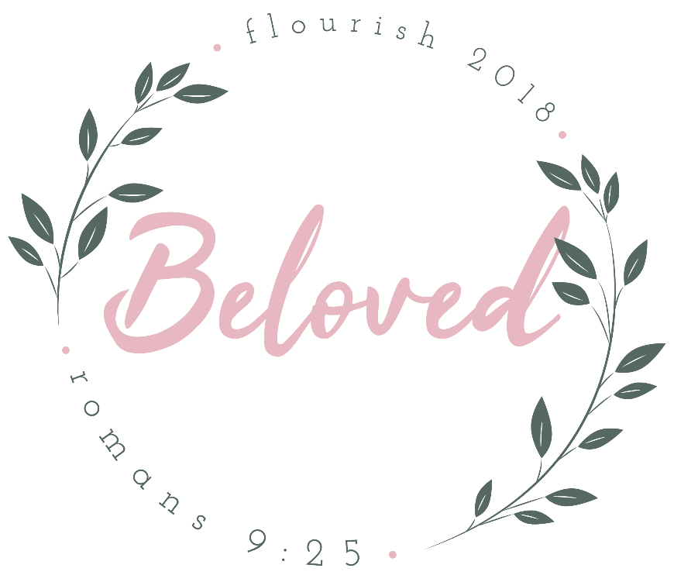

Schedule
Friday
6:30pm Check-in
7:00pm Main Session
8:00pm Small Groups
8:30pm Late Night
10:30pm Get Ready for Bed
11:30pm Lights Out
Saturday
8:45am Breakfast
9:30am Main Session
10:45am Breakout Session I
11:45am Breakout Session II
12:45pm Lunch
1:45pm Battlefield Houston and Service Project
4:15pm Breakout Session III
5:00 pm Change for dinner
5:30pm Dinner
6:30pm Change for main session and group picture
7:00pm Main Session
8:00pm Small Groups
8:30pm Parent Pick Up

What to Bring
Bible
Pen
Sleeping Bag/Blanket
Pillow
Air Mattress (optional)
Toiletries
Bath Towel
Clothes for the weekend
Masquerade Dinner Clothes
What to Leave at Home
Cell Phones and all electronics!
*Digital cameras are permitted

